Blockly 案例——对一个正整数进行因式分解

案例说明：

整数分解，又称质因子分解。在数学中，整数分解问题是指:给出一个正整数，将其写成几个素数的乘积。例如，给出45这个数，它可以分解成3^2×5。根据算术基本定理，这样的分解结果应该是独一无二的。这个问题在代数学、密码学、计算复杂性理论和量子计算机等领域中有重要意义。

利用blockly实现整数分解

思路：先对输入的正整数n进行是否质数的判断，若是质数，直接输出n=n×1。若是合数，就用它去除从2开始的自然数，找出第一个因数j，再使n=n÷j，重复刚才的步骤，直到n成为质数，即最大的因数，再输出所有因数。

模块展示：

：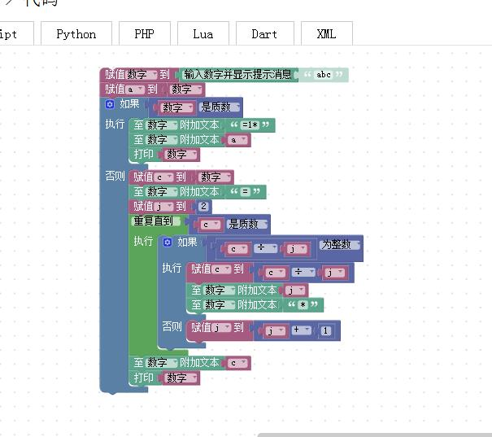

运行结果：

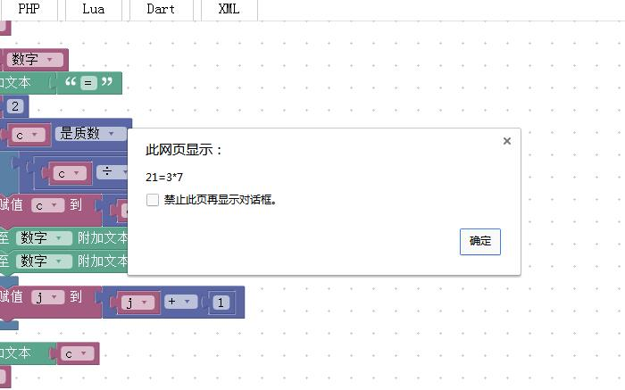

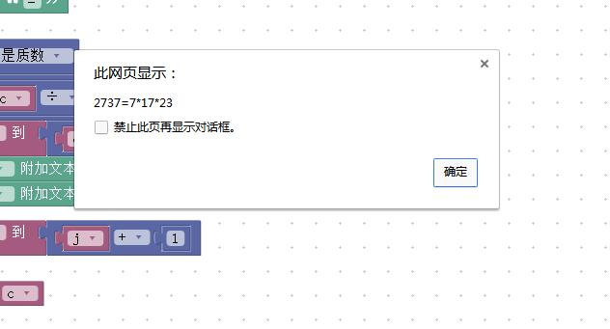

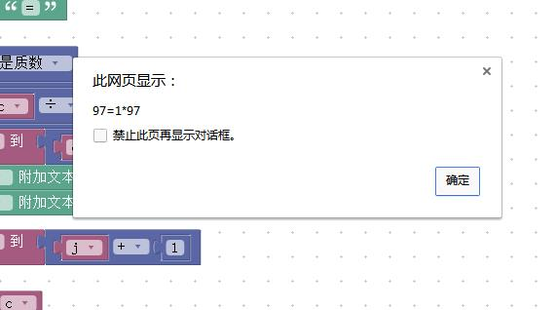

XML代码：

<xml xmlns="http://www.w3.org/1999/xhtml">

<variables>

<variable type="" id=".d?sxIUePWsm[+F[!l?(">a</variable>

<variable type="" id="*7JCe;3*#}p/(=t.Pbt!">b</variable>

<variable type="" id=")*My0O}?z$q[J,IsqE9|">c</variable>

<variable type="" id="NrwG|CuKSl-ke1?O@4#)">d</variable>

<variable type="" id="e~TCdGNCokg;1WYc)UrI">m</variable>

<variable type="" id="!AIKEs?`pMRtJgNKJYR?">数字</variable>

<variable type="" id="ACl}?3;=eLOuNhd3X,F)">n</variable>

<variable type="" id="UJNd=m[tJ77[ra~T#Xmp">i</variable>

<variable type="" id="O1]naO[bD[Y/4zW/pL((">项目</variable>

<variable type="" id="d/oQ%C6gIk?t]@nYcxdw">j</variable>

</variables>

<block type="variables_set" id="`AR|R=CoMg[nY+eXA=4a" x="-87" y="-187">

<field name="VAR" id="!AIKEs?`pMRtJgNKJYR?" variabletype="">数字</field>

<value name="VALUE">

<block type="text_prompt_ext" id="b)q3IlT%U-2EHskQ8cvZ">

<mutation type="TEXT"></mutation>

<field name="TYPE">TEXT</field>

<value name="TEXT">

<shadow type="text" id="~~EMQ8n4-X8ZG#gSHqo{">

<field name="TEXT">abc</field>

</shadow>

</value>

</block>

</value>

<next>

<block type="variables_set" id="I+[nT[G}!Po?qt~Ui[,e">

<field name="VAR" id=".d?sxIUePWsm[+F[!l?(" variabletype="">a</field>

<value name="VALUE">

<block type="variables_get" id=")MZY}g[Q[wSGV:Q0:N#n">

<field name="VAR" id="!AIKEs?`pMRtJgNKJYR?" variabletype="">数字</field>

</block>

</value>

<next>

<block type="controls_if" id="mp%05m0Ysxv9s5H.%fJ[">

<mutation else="1"></mutation>

<value name="IF0">

<block type="math_number_property" id="1Y`%lX9s|GYn@vDby}sW">

<mutation divisor_input="false"></mutation>

<field name="PROPERTY">PRIME</field>

<value name="NUMBER_TO_CHECK">

<shadow type="math_number" id=":U,8vx*j.q(`LflW1yq3">

<field name="NUM">0</field>

</shadow>

<block type="variables_get" id="I}0!Jol{o:ju+q-r*yjW">

<field name="VAR" id="!AIKEs?`pMRtJgNKJYR?" variabletype="">数字</field>

</block>

</value>

</block>

</value>

<statement name="DO0">

<block type="text_append" id="d:;aY1/ycu5{Ag#w?@:1">

<field name="VAR" id="!AIKEs?`pMRtJgNKJYR?" variabletype="">数字</field>

<value name="TEXT">

<shadow type="text" id="x?vnq9!mh2gHakELS1HO">

<field name="TEXT"></field>

</shadow>

<block type="text" id="sAu$A!aP?Cwq,bF99MZC">

<field name="TEXT">=1*</field>

</block>

</value>

<next>

<block type="text_append" id="#GWF{{4}8EV[p1(i[#G`">

<field name="VAR" id="!AIKEs?`pMRtJgNKJYR?" variabletype="">数字</field>

<value name="TEXT">

<shadow type="text" id="wfJgnD,eNjeM@i;xa3)d">

<field name="TEXT"></field>

</shadow>

<block type="variables_get" id="E8euyEMw20WRkc_lo|p.">

<field name="VAR" id=".d?sxIUePWsm[+F[!l?(" variabletype="">a</field>

</block>

</value>

<next>

<block type="text_print" id="/OYw/uz-fdyKj8!.o=}/">

<value name="TEXT">

<shadow type="text" id=",,V~CHq]!Z~*OUKdYWS/">

<field name="TEXT">abc</field>

</shadow>

<block type="variables_get" id="5L,ft$Z32S:?.[qm{{`j">

<field name="VAR" id="!AIKEs?`pMRtJgNKJYR?" variabletype="">数字</field>

</block>

</value>

</block>

</next>

</block>

</next>

</block>

</statement>

<statement name="ELSE">

<block type="variables_set" id="(`G@WE9/G.o_PIZi~T*t">

<field name="VAR" id=")*My0O}?z$q[J,IsqE9|" variabletype="">c</field>

<value name="VALUE">

<block type="variables_get" id="rb1$.iC:StYfEUdpfFx4">

<field name="VAR" id="!AIKEs?`pMRtJgNKJYR?" variabletype="">数字</field>

</block>

</value>

<next>

<block type="text_append" id="-%u,_JVP3SZaql0SZT_O">

<field name="VAR" id="!AIKEs?`pMRtJgNKJYR?" variabletype="">数字</field>

<value name="TEXT">

<shadow type="text" id="Q*m{)d4Xh95_^$6fVrXd">

<field name="TEXT"></field>

</shadow>

<block type="text" id="G~_ydwc0G;w4;U_*ClTP">

<field name="TEXT">=</field>

</block>

</value>

<next>

<block type="variables_set" id="fQDc=jsic[0c2I[o*yRl">

<field name="VAR" id="d/oQ%C6gIk?t]@nYcxdw" variabletype="">j</field>

<value name="VALUE">

<block type="math_number" id="E:ZR(ya$+dAA87V#BNk(">

<field name="NUM">2</field>

</block>

</value>

<next>

<block type="controls_whileUntil" id="iYd4]_Q}Y-.LGyo]#jH)">

<field name="MODE">UNTIL</field>

<value name="BOOL">

<block type="math_number_property" id="}9N1CP_aqLh!y0`BKtKx">

<mutation divisor_input="false"></mutation>

<field name="PROPERTY">PRIME</field>

<value name="NUMBER_TO_CHECK">

<shadow type="math_number" id="jrZA0rah}+!h(/RsRZO/">

<field name="NUM">0</field>

</shadow>

<block type="variables_get" id="[yK|zLa(^4j3/9wvqU08">

<field name="VAR" id=")*My0O}?z$q[J,IsqE9|" variabletype="">c</field>

</block>

</value>

</block>

</value>

<statement name="DO">

<block type="controls_if" id="#)2wP_z:psCR:*Z([qfR">

<mutation else="1"></mutation>

<value name="IF0">

<block type="math_number_property" id="K(vl9(W~YIj2T|D`%}9I">

<mutation divisor_input="false"></mutation>

<field name="PROPERTY">WHOLE</field>

<value name="NUMBER_TO_CHECK">

<shadow type="math_number" id="|yVNeW-uj3u*t}?Rb_u$">

<field name="NUM">0</field>

</shadow>

<block type="math_arithmetic" id="K:E7T$n;DXMu:uv-/e:%">

<field name="OP">DIVIDE</field>

<value name="A">

<shadow type="math_number" id="`-7Qh6t1A9{_EhS;1ubj">

<field name="NUM">1</field>

</shadow>

<block type="variables_get" id="-5yK4Scw.E#mt2x;)-Yn">

<field name="VAR" id=")*My0O}?z$q[J,IsqE9|" variabletype="">c</field>

</block>

</value>

<value name="B">

<shadow type="math_number" id="NTzEqk%+)bioEUkbtlco">

<field name="NUM">1</field>

</shadow>

<block type="variables_get" id="s)0Fbqb$pTisR.]/D@0U">

<field name="VAR" id="d/oQ%C6gIk?t]@nYcxdw" variabletype="">j</field>

</block>

</value>

</block>

</value>

</block>

</value>

<statement name="DO0">

<block type="variables_set" id=")0*MK,RKo,8pE4HhK`h9">

<field name="VAR" id=")*My0O}?z$q[J,IsqE9|" variabletype="">c</field>

<value name="VALUE">

<block type="math_arithmetic" id="{RGI1.$V6KqG{%{)|zqI">

<field name="OP">DIVIDE</field>

<value name="A">

<shadow type="math_number" id="`-7Qh6t1A9{_EhS;1ubj">

<field name="NUM">1</field>

</shadow>

<block type="variables_get" id="yb?@BLw6)EteE$1+^_R~">

<field name="VAR" id=")*My0O}?z$q[J,IsqE9|" variabletype="">c</field>

</block>

</value>

<value name="B">

<shadow type="math_number" id="NTzEqk%+)bioEUkbtlco">

<field name="NUM">1</field>

</shadow>

<block type="variables_get" id="]:.HKneFWt({044~l!oi">

<field name="VAR" id="d/oQ%C6gIk?t]@nYcxdw" variabletype="">j</field>

</block>

</value>

</block>

</value>

<next>

<block type="text_append" id="_m,}-bNzN$$xRL6SCi7@">

<field name="VAR" id="!AIKEs?`pMRtJgNKJYR?" variabletype="">数字</field>

<value name="TEXT">

<shadow type="text" id="fJn$Yvx2G_r7]OUwWd(A">

<field name="TEXT"></field>

</shadow>

<block type="variables_get" id="CYbq%qyzcYn^y9*e7JHB">

<field name="VAR" id="d/oQ%C6gIk?t]@nYcxdw" variabletype="">j</field>

</block>

</value>

<next>

<block type="text_append" id="rGI;L]q6sJze/*E45F$[">

<field name="VAR" id="!AIKEs?`pMRtJgNKJYR?" variabletype="">数字</field>

<value name="TEXT">

<shadow type="text" id="b+vEZS];9%$w%?qVtejk">

<field name="TEXT"></field>

</shadow>

<block type="text" id="ju-i~1tceG(zLMNrwrur">

<field name="TEXT">*</field>

</block>

</value>

</block>

</next>

</block>

</next>

</block>

</statement>

<statement name="ELSE">

<block type="variables_set" id="si]Bq(#*v}O9YXA=bCf#">

<field name="VAR" id="d/oQ%C6gIk?t]@nYcxdw" variabletype="">j</field>

<value name="VALUE">

<block type="math_arithmetic" id="_48e(X-BOdS{dpUf0c5#">

<field name="OP">ADD</field>

<value name="A">

<shadow type="math_number" id="`-7Qh6t1A9{_EhS;1ubj">

<field name="NUM">1</field>

</shadow>

<block type="variables_get" id="gX5^_:l0}LfLDpdxh-}T">

<field name="VAR" id="d/oQ%C6gIk?t]@nYcxdw" variabletype="">j</field>

</block>

</value>

<value name="B">

<shadow type="math_number" id="NTzEqk%+)bioEUkbtlco">

<field name="NUM">1</field>

</shadow>

<block type="math_number" id="3.ZC2mc7=}v:nsg/7^yG">

<field name="NUM">1</field>

</block>

</value>

</block>

</value>

</block>

</statement>

</block>

</statement>

<next>

<block type="text_append" id="^jT9)g|O,H3hrw~;2Qc]">

<field name="VAR" id="!AIKEs?`pMRtJgNKJYR?" variabletype="">数字</field>

<value name="TEXT">

<shadow type="text" id="fJn$Yvx2G_r7]OUwWd(A">

<field name="TEXT"></field>

</shadow>

<block type="variables_get" id="~8KKVOy2p]I4[dk:,N|x">

<field name="VAR" id=")*My0O}?z$q[J,IsqE9|" variabletype="">c</field>

</block>

</value>

<next>

<block type="text_print" id="_K#sB+Yjp2#9UT,PCh|~">

<value name="TEXT">

<shadow type="text" id=",,V~CHq]!Z~*OUKdYWS/">

<field name="TEXT">abc</field>

</shadow>

<block type="variables_get" id="r8;YB5A6n$tR`0cCUtgh">

<field name="VAR" id="!AIKEs?`pMRtJgNKJYR?" variabletype="">数字</field>

</block>

</value>

</block>

</next>

</block>

</next>

</block>

</next>

</block>

</next>

</block>

</next>

</block>

</statement>

</block>

</next>

</block>

</next>

</block>

</xml>